PCT Punch Clock Timer
Version 0.101
06/21/15

Table of Contents
Overview 1
Menus 2
Tasks 2
Reports 3
Help 3
About 3
Operation 3
Active Task Button 3
Task Button Right-Click 4
Add a New Task 4
Edit Tasks 5
Add Hidden Tasks for the Day 5
Misc Task 6
Order Tasks 6
Report Week's Time 7
Reports on Notes 7
Configuration 7
Logs and Backups 8
Further Reporting 8
PCT_DB 9
PCT_Notes_DB 9

Overview
PCT Punch Clock Timer is designed as a desktop tool to capture time spent on various project tasks. It works in harmony with the HP PPM (Project Portfolio Manager) time sheets. PCT may be thought of as a mufti-button chess clock. You may define an unlimited number of buttons to represent the Projects and Tasks on which you are spending time. One button is active and recording time at any given moment. All buttons can be stopped if you are not billing time for the current moment. A single task may be set to begin recording time at program start.
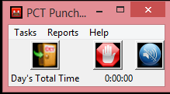
The program initially starts with no projects or tasks defined. Use the Exit door button to close the program. If there is a task accumulating time, the Stop button will halt that time accumulation. The Silence button may be used to quiet the button alert function (button turn a yellow background) if the button has an alert function set (button has a teal background) to remind you that it has been pressed and are you still recording time for the selected task.
Most fields menus and buttons have tool tips to help you determine what has to happen at each point.

PCT uses a SQLite3 database to record time, the program being written in Python 3. Projects and tasks are defined in the tool, and time spent on them is recorded for each day. Miscellaneous tasks are predefined in the database.
Weekly reports of time spent are available, and may be used to fill in a PPM time sheet.
Project notes may be taken in the tool also, with available reports written to text files.

Menus

Tasks
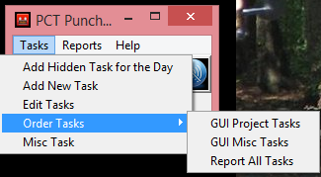
Tasks menu is where new projects and tasks are entered and managed. Tasks may be defined as hidden if they are not frequently used. Shown tasks always appear on the screen. Hidden tasks appear when they are added to the screen for the day. On subsequent days they again are hidden until made to show. Task options are edited on the Edit Tasks menu. Task order is adjusted for Project Tasks on the screen, Miscellaneous Tasks on the screen or all tasks in the reports. Reports may be ordered so they more closely follow the order in the PPM time sheet, the on-screen order may be arranged by frequency of use. Miscellaneous tasks may be added to a time record to remind you that such time happened, so you may accurately reflect all of your time in the PCT tool and in PPM. The week's total time should approach the same value, providing a cross check that you properly transcribed your time from PCT to PPM.

Reports
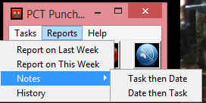
The Reports menu is where you see the time for current or previous week. You may also see the notes you have entered, ordered by task or by date. Notes reports are written to text files and placed in a folder controlled by a configuration option. The default is reports under the program folder. History allows for the viewing and editing of all tasks for any arbitrary date.

Help
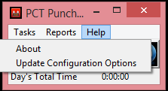
The Help menu displays the About dialog with the program version information. It also lets you manage configuration options.

About
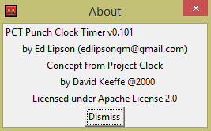

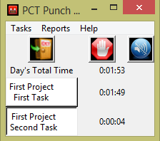
Operation

Active Task Button
Click a task button to activate the clock for that button. Click a different task button to switch. The Stop button will halt all time accumulation.

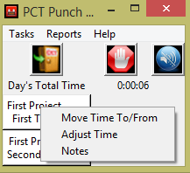
Task Button Right-Click
Task buttons have a set of right click options. You may move time to the right clicked task from another task. More time than recorded may be moved, setting the source/from task to zero time. Use the List button to display the possible source/from tasks, and enter the time in the field.
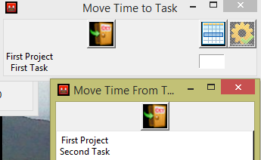

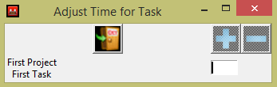
You may also adjust the time up or down for a task, entering the number of minutes and using the Plus or Minus button to adjust the time accordingly. You may subtract more time than that recorded to set the time to zero.

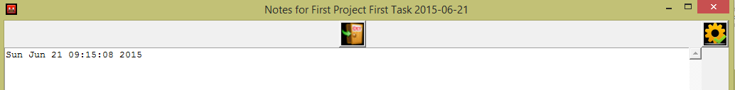
Notes may be added for a task. A text entry box will open for you to record notes. If there are previous notes for the tasks, they will be displayed under the current day's note so you may refer to them. The number of previous days notes and the text window sizes are configured in the configuration section of the application.

Add a New Task
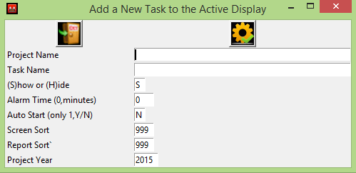
Fill in the fields as indicated. Project name is optional. Task name is required. This is where you set the tasks initial display option, to be Shown on the initial start of the program or Hidden until needed. You may set the alarm time so you are reminded that the button is recording time, or use zero to not have an alarm. The Silence button may be used to stop the alarm for that time recording session. Auto Start is used to tell the program at start up whether to begin recording time or not. Only one is auto started, the one sorted to the top of the display screen. Sort order for the screen and reports are entered. The Project Year is used to separate tasks by calendar year.
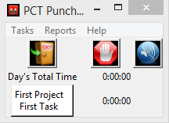
The Process gear button is used to cause the window to close and add the Project Task. The newly added Project Task appears on the screen, even if it has been marked as hidden. The hidden attribute is honored on subsequent starts of the program.

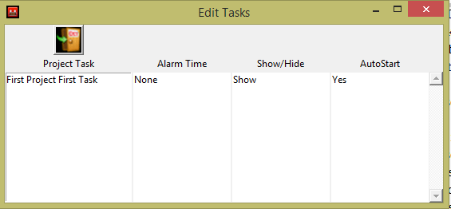
Edit Tasks
The Edit Tasks opens a window which shows all tasks. Click on a task name to open a dialog where the task properties may be updated.
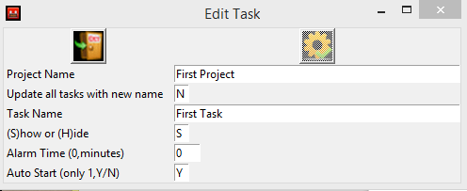
You may edit the project name and the task name. You may reset all of the tasks belonging to a given project to the new project name by changing the N to a Y for the Update all tasks with new name. The process button is not active until you make some change on the screen.

Add Hidden Tasks for the Day
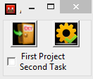
This menu item will display a list of defined but not shown tasks, so you may bring them forward for use for a day. This option is useful when you have 50 tasks as it keeps the application normally smaller on the desktop, showing only those tasks in active use. Select the tasks to bring forward and press the Process button. The main task window will change from showing one task to two.
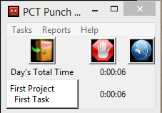
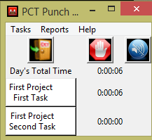

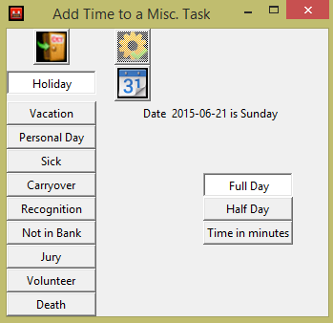
Misc Task
This menu button will open a dialog where you can select the type of miscellaneous task for recording. While they don't generate charges in the HP PPM system, the days are used to ensure your time sheet has the required number of hours for the week. It has been added to PCT so you remenber that you had such a day and will see it in the weekly report of time, from which you transcribe you time to the PPM time sheet.
Select the tpye of day, a date, and whether it is a full, half or how many minutes. A full day is a configuration option and may be changed based on where your work and what you require. Press the active Process button (it is inactive to start) to cause the day to be recorded

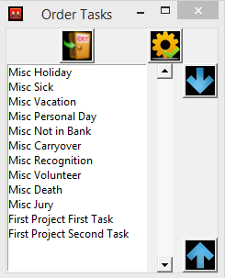
Order Tasks
The three order tasks sub-menu items all work the same. You select a task from the list and use the up and down arrows to move it to a new position in the list. The process button will cause all of the appropriate sort order information in the database to be adjusted to match the current order of the list.
GUI Task order effects the sequence of shown tasks or the hidden tasks in the add hidden tasks for the day dialog. Hidden tasks are always shown at the end of the list.
GUI Misc is used to sequence the miscellaneous task buttons in the Miscellaneous day dialog.
The Report order dialog is used for the reports on the week's time. You should make it match the PPM time sheet order to facilitate the transcriptin of the time from PCT to PPM time sheets.

Report Week's Time
This report is the week Monday to Sunday time. It rounds up to 10ths of an hour (as lawyers do). It is either the previous week, from the day of the report, or the current week. It cross foots as the PPM time sheet does but owing to the rounding differences it will not cross foot exactly.
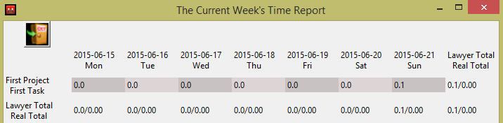

Reports on Notes
The Notes reports offer two options and a configuration. You may report on Notes by date then task or by task then date. The number of weeks back to include in the report is a configuration option. The text reports are written to files, generations of files to retain is a configuration option, in a location specified in the configuration. The default is a reports folder under the program folder.

Configuration
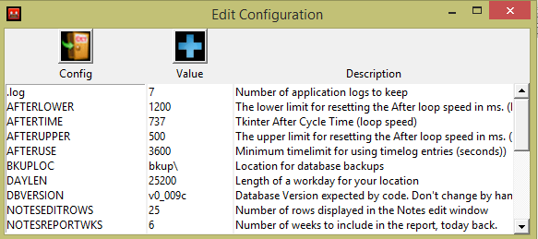
The configuration dialog opens the window with all of the configuration options. Click on the option key to edit it.

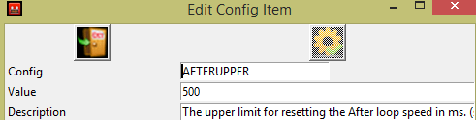
A new window will open.

You may also add options which are not currently defined but are used by the program. Any such option, which is missing but may be set if it exists, will be logged in the program log.
WARNING Could not find configuration item SHOWHIDROWLIM

Logs and Backups
There is a process log written each time the program starts. It is written into the program directory. A configuration option controls how many generations of the logs will be kept. One of the key items in the log is the time factor adjustment. Python tkinter loops only guarantee to wait as long as the repeat, but can wait longer. The program will attempt to adjust the loop speed at program exit so next time it will more accurately reflect the real time captured, where one second is a real clock second. On a busy system the repeat cycle may have to be set fast.
The time DB is backed up at each program start, into a location specified in the configuration. The default location is a folder under the programs folder. The number of generations is control by a configuration option too. The Notes DB is backed up only when written to. Location and generations are controlled by configuration.

Further Reporting
The generally available SQLite3 engine (http://www.sqlite.org/download.html) for your appropriate platform may be used to create any necessary reports not currently implemented in PCT. There are two databases, one for tasks and time and one for notes.

PCT_DB
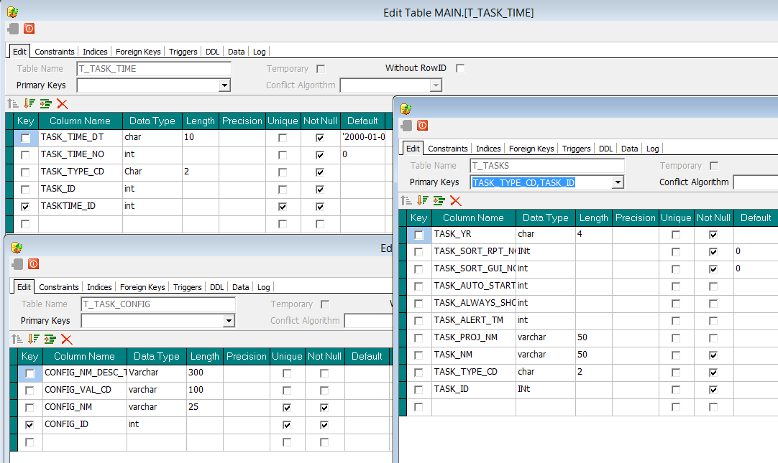

PCT_Notes_DB
